Program 1
Program 2
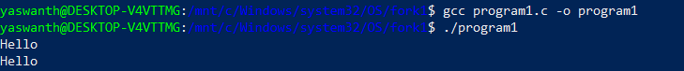
Program 3
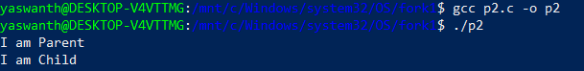
Program 4
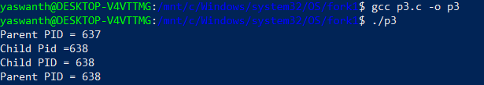
Program 5
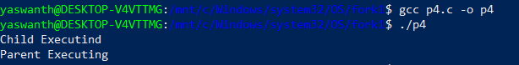
Program 6
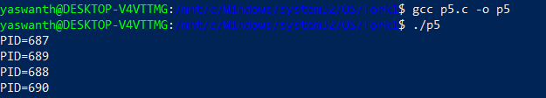

Program 7
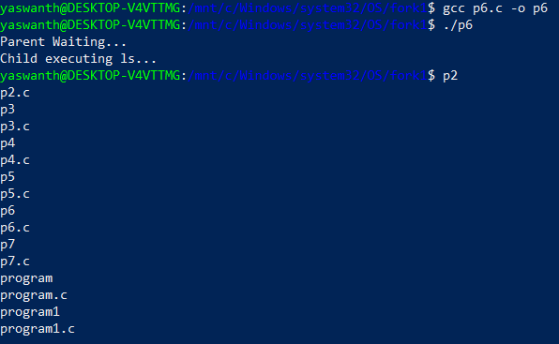
Program 8
